CHANGES No: 2
to the
TENDER DOSSIER

Publication Ref: EuropeAid/136649/IH/SUP/TR
Subject: Supply for Improving the Crime Scene Investigation Capacity of Turkey-Relaunch
Location - Europe (non EU) / Turkey (TR)
The following alterations/changes are made to the Tender Dossier:

ANNEX II + III: technical specıfıcatıons + technıcal offer
3. Technical Specifications Table
Former Text
1.2.17.7. Standard factory front and rear bumper with grille guard. Stainless front, rear and side protection barriers shall be mounted on the vehicle.
Shall read as new text:
1.2.17.7. Apart from standard factory front and rear bumper, exterior front, rear and side protection barriers shall be mounted on the van in a similar way on the sample images below. The barriers should be made of metal pipes and should be painted with matt black color electrostatic powder. Front protection barrier should include grills to protect front headlights and fog lamps. Rear protection barrier should include a step for easy entry to the van.
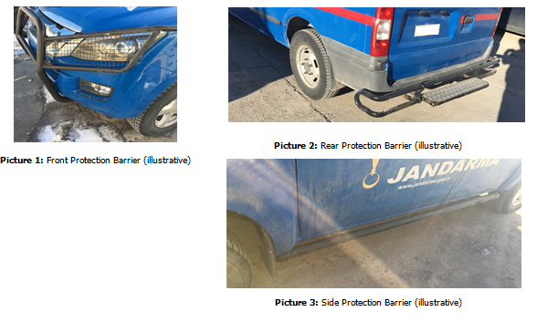
ANNEX II + III: technical specıfıcatıons + technıcal offer
3. Technical Specifications Table
Former Text
1.4.2.7.5. The consideration of placing a steel box inside the cupboard will be incorporated into the design. Features of the safe shall be as follows:
Shall read as new text:
1.4.2.7.5. The consideration of placing a safe inside the cupboard will be incorporated into the design. Features of the electronic safe shall be as follows:

ANNEX II + III: technical specıfıcatıons + technıcal offer
3. Technical Specifications Table
Former Text
1.4.6.1. Foldable Power Lighting Tower, which can operate telescopically and pneumatically, shall ascend at least 1.8 (one point eight) m above from the vehicle roof and produce at least 14.000 (fourteen thousand) lumens of light by at least 2 (two) light heads, shall be mounted on suitable place of the vehicle roof.
Shall read as new text:
1.4.6.1. Foldable Power Lighting Tower, which can operate telescopically and pneumatically or hydraulic, shall ascend at least 1.8 (one point eight) m above from the vehicle roof and produce at least 14.000 (fourteen thousand) lumens of light by at least 2 (two) light heads, shall be mounted on suitable place of the vehicle roof.
***
All other terms and conditions of the tender dossier remain unchanged. The above alterations and /or corrections to the tender dossier are integral part of the tender dossier.

